**Index.html**

<!DOCTYPE html>

<html>

<head>

<title>search</title>

<meta charset="UTF-8">

<meta name="viewport" content="width=device-width, initial-scale=1.0">

<link rel="stylesheet" href="design.css">

</head>

<body>

<center>

<form method="GET" action="searchengine">

Enter Your Search :

<input type="text" name="query">

<br>

<br>

<br>

<br>

<button type="submit" name="ggl" value="Google">Search With Google</button>

<br>

<br>

<button type="submit" name="bng" value="Bing">Search With Bing</button>

</form>

</center>

<br>

<br><br>

<br>

<br>

<br>

<footer class="footer" style="background-color: #ADD8E6;">

<div class="container">

<div class="row">

<div class="col-md-12 text-center">

<br/>

<center>

By Viraj Thakkar <br>

201806100110094

</center>

</div>

</div>

</div>

</footer>

</body>

</html>

**Searchegine.java**

import java.io.IOException;

import java.io.PrintWriter;

import javax.servlet.ServletException;

import javax.servlet.http.HttpServlet;

import javax.servlet.http.HttpServletRequest;

import javax.servlet.http.HttpServletResponse;

/**

*

* @author Viraj

*/

public class searchengine extends HttpServlet {

protected void processRequest(HttpServletRequest request, HttpServletResponse response)

throws ServletException, IOException {

response.setContentType("text/html;charset=UTF-8");

try (PrintWriter out = response.getWriter()) {

String Qry = request.getParameter("query");

String Googlekey = request.getParameter("ggl");

if (Qry.equals("movies") ||Qry.equals("online games") ||Qry.equals("online shopping") ||Qry.equals("games"))

{

response.sendError(response.SC_BAD_REQUEST,"RESTRICTED KEYWORD DETECTED IN INPUT");

}

else{

if("Google".equals(Googlekey))

{

response.sendRedirect("https://www.google.com/search?q="+Qry);

}

else

{

response.sendRedirect("https://www.bing.com/search?q="+Qry);

}

}

}

}

**Web.xml**

<?xml version="1.0" encoding="UTF-8"?>

<web-app version="3.1" xmlns="http://xmlns.jcp.org/xml/ns/javaee" xmlns:xsi="http://www.w3.org/2001/XMLSchema-instance" xsi:schemaLocation="http://xmlns.jcp.org/xml/ns/javaee http://xmlns.jcp.org/xml/ns/javaee/web-app_3_1.xsd">

<servlet>

<servlet-name>searchengine</servlet-name>

<servlet-class>searchengine</servlet-class>

</servlet>

<servlet-mapping>

<servlet-name>searchengine</servlet-name>

<url-pattern>/searchengine</url-pattern>

</servlet-mapping>

<session-config>

<session-timeout>

30

</session-timeout>

</session-config>

</web-app>

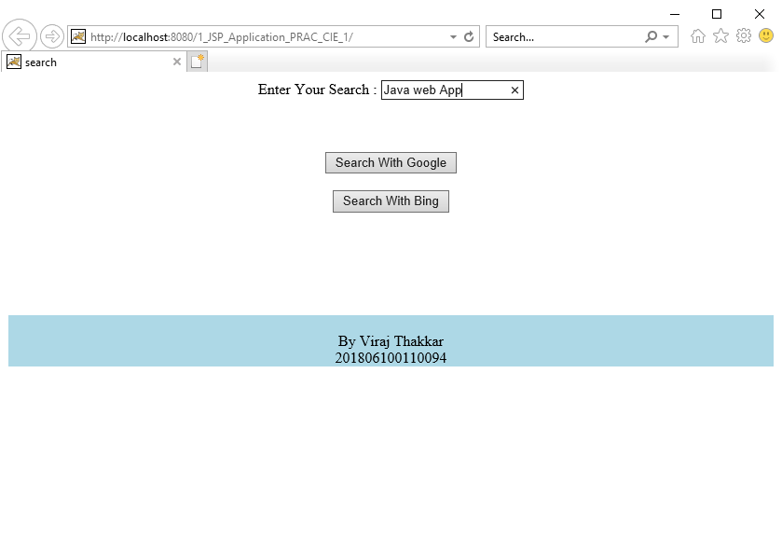

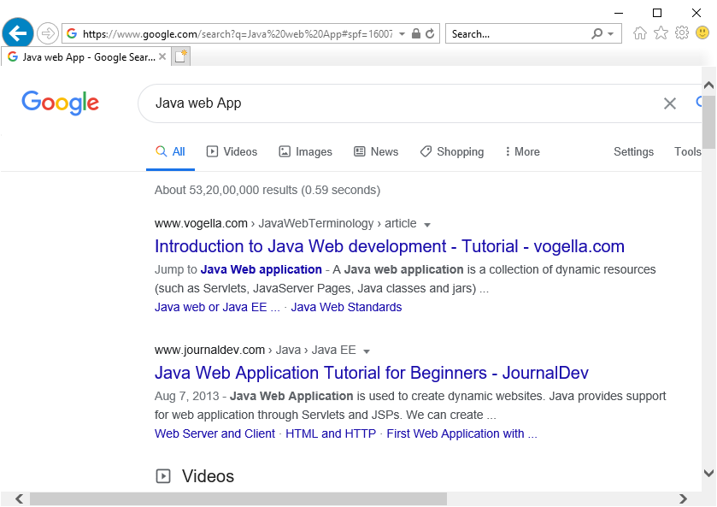

Top of Form

Top of Form

Bottom of Form